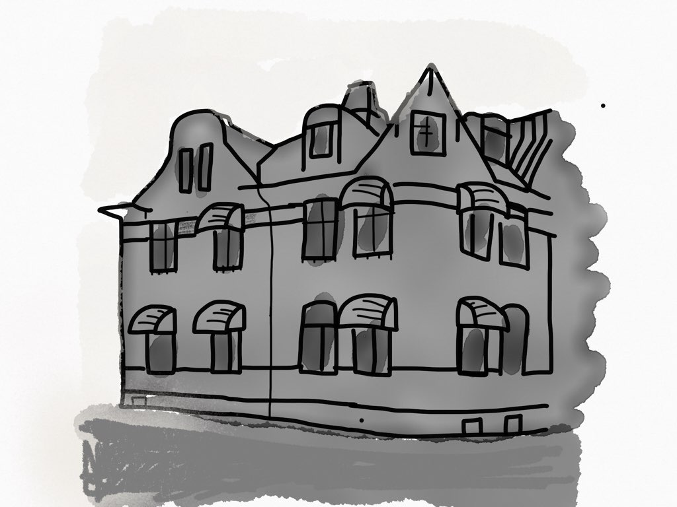

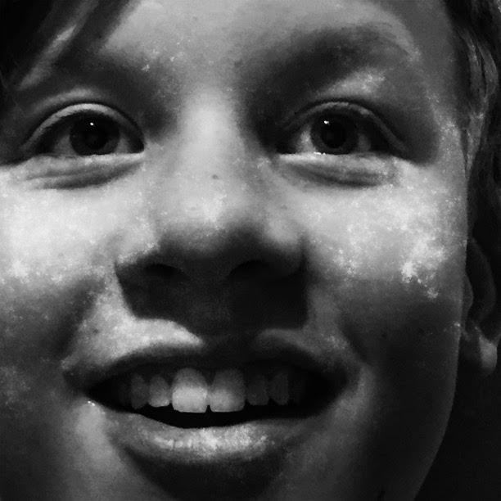

This is The Hotel Mystery told by Mark Brown. He is a 12-year-old boy who loves detective stories and birds, especially crows. He is always looking for a mystery to solve. His parents own the Hotel and he is helping them out.

PART 1

Chapter 1
The Day Before the Grand Opening

Everyone in the little town could see the hotel from where they lived. The hotel had been there for many years.

Two years ago, Mr. & Mrs. Brown bought the hotel. The wanted to restore it to its former glory.

After nearly two years of hard work the hotel was looking better than ever. The grand opening was not far away.

Henry Foyer, the baker, walked up to the hotel. He carried a big wooden box with bread. He entered and heard a familiar voice from reception.

“Hello Henry. Do you need any help?” said Mark.
“Hi Mark. Thank you, I’m ok,” said Henry. “Is Patricia here?”
“Yes,” said Mark. “She’s in the kitchen”.

Mark Brown was Ben and Beatrice Brown’s son. He worked at the hotel.

Henry walked to the kitchen. Patricia was busy cooking. She smiled when she saw Henry.

“Hi Henry. Put the bread over there, please,” said Patricia. “Do you want a
glass of water?”
“Hi Pat,” said Henry. “Yes please. Do you need any help?”
“No, I’m ok,” said Patricia. “Are you coming tomorrow night, for the party?”

Henry grew up in the little town. His father and grandfather were bakers too.

PART 1

Chapter 1
The Day Before the Grand Opening

Two years ago, Mr. & Mrs. Brown bought The Ellington Hotel. It was an old hotel, close to the church in the little town.

After two years of hard work the hotel was looking better than ever.

Henry Foyer was a baker. He walked up to the hotel with some bread. He talked to Mark Brown in reception. Then he continued to the kitchen. He talked to Patricia who was the chef. He gave her the bread.

Mark Brown was Ben and Beatrice Browns son, He worked at the hotel.

Henry grew up in the little town. His father and grandfather were bakers too.

PART 1

Chapter 2

Staff Meeting

Beatrice announced a staff meeting at three o’clock. The office was full of people, sitting around the table.
Ben Brown, one the managers, was a man of about 50. He was quite tall and slim.
Beatrice, the other manager, was about the same age as her husband. She was a cheerful woman with brown hair and glasses.
Ron Hallmark, the caretaker, was a grumpy old man in his sixties. He was always wearing a hat. Nobody had ever seen him without it.
Patricia Pear, the chef, had long black hair and strong arms. She had a dog called Louie, a black-and-white terrier.
Mark, well everyone recognized him as the guy with one eye. He got wounded as a kid and had to remove his right eye.

“Well, now,” said Beatrice. “The hotel’s grand opening is under way.” She waved a to-do-list as if it was very warm in the room.
“Well, we are also expecting a very famous and important guest, arriving tomorrow,” said Ben. “Mr. Hall, George Hall, the art dealer. We have to take very good care of him.”

Mark wrote his name on a piece of paper. George Hall. The staff members left the room and continued their preparations. They all went to bed around midnight.

Chapter 2

Staff Meeting

Beatrice announced a staff meeting at three o’clock. Everyone was sitting around the table.
Ben Brown, the manager, was 50 years old. He was quite tall and slim.
Beatrice Brown was 50 years old too. She was a cheerful woman with brown hair and glasses.
Ron Hallmark, the caretaker, was a grumpy old man. He was always wearing a hat.
Patricia Pear, the chef, had long black hair and strong arms. She had a dog called Louie.
Mark, was the guy with one eye. He got wounded as a kid.

“Well, now,” said Beatrice. “The hotel’s grand opening is under way.” She waved a to-do-list as if it was very warm in the room.
“Well, we are also expecting a very famous and important guest, arriving tomorrow,” said Ben. “Mr. Hall, George Hall, the art dealer. We have to take very good care of him.”

Mark wrote George Hall on a piece of paper. The staff members left the room.. They all went to bed around midnight.

PART 2

Chapter 3
Short on Money

Finally, it was time for the grand opening. Mark walked down to reception and opened the front door. He turned on the computer to search for someone.

Ben and Beatrice was talking in the office. The door was opened so Mark heard them talking. Beatrice was whispering something about kitchen equipment and that they had to pay 20.000kr.

The front door opened. It was Susan and Steven from the theatre. They had a gift for Ben and Beatrice to celebrate the grand opening.

“Welcome to the grand opening of the hotel,” said Mark.
“Ooohhh, congratulations to all of you,” said Susan.
“Are you staying for dinner?” said Mark.
“Yes, of course,” said Susan. “See you later!”

Susan and Steven were actors running the local theatre. They were Ben and Beatrice friends and had been painting all the rooms during summer.

Mark was on his way to his room when he heard Patricia on the phone. He heard her talking to someone about her dog Louie.

“It’s an expensive surgery,” said Patricia. “I need 20.000kr and I need to find someone to replace me in the kitchen.”

Patricia was a great chef. She met Beatrice when they were working at the same café many years ago.

PART 2

Chapter 4
The Guest

At two o’clock Mark heard a car outside the hotel. He recognized the man walking through the door. It was Mr. Hall, George Hall, the art dealer.

“Welcome Mr. Hall,” said Ben.
“This is a very expensive painting,” said George Hall holding something in his hand. “No one can touch it, except me.”
“Of course,” said Ben.

The painting was wrapped up as a gift with blue paper and a red ribbon. Mark looked at it. And then he carried Mr. Halls bags upstairs.

Ron Hallmark, the caretaker, came to reception to talk to Mark. He had a newspaper in his hand.

“Mark,” said Ron. “Look!”
“What is it?” said Mark.
“It’s about a missing painting.” said Ron. “Read!”

Mark read the news about the missing painting. It was stolen last night at the gallery downtown. (INSERT: News article with picture.)

“There are criminals everywhere these days,” said Ron, shaking his head, before he left.

Mark noticed the name of the painter on a piece of paper.

The front door opened and Henry walked in, again. He said Patricia called about some extra bread. On his way, back he stopped and talked to Mark.

“Are you coming for the grand opening dinner?” said Mark.
“Yes of course,” said Henry. “If I’m done at the bakery.”
“Good,” said Mark. “I hope you will make it.”
“I hope so too,” he said. “I’m starting a café next to the bakery. So, I need all the money I can get.”

Henry left the hotel and Mark searched the internet again. This time about a painter.

PART 3

Chapter 5
The Grand Opening

At seven o’clock the dining room was full of people. There were guests staying at the hotel, locals from town and friends.

“Welcome! We are so happy to see you,” said Beatrice.
“We bought this hotel two years ago, said Ben. “Two years of hard work. But now we are here.”
“Let the party begin!” said Ben and Beatrice.

Mark heard everything from reception. Someone had to work and look after Louie.

Susan and Steven were the last guests to leave the party. They were dancing through the lounge saying good bye. Suddenly they heard someone screaming upstairs. Mark ran upstairs followed by Susan and Steven.

PART 3

Chapter 6
The Missing Painting

“My painting is gone,” yelled Mr. Hall. “Do you have any idea how expensive it is?”

Mr. Hall stood there in the hallway outside his room. In his hand, he had the empty frame. The door next to Mr. Hall’s opened and Patricia and Henry came out. Ben and Ben and Beatrice came down from the third floor. Beatrice had the master key in her hand.

“My painting is gone!” yelled Mr. Hall again. “Do you have any idea how expensive it is? It’s worth at least 30.000kr”. His face was all red.” You are going to pay for this!” yelled Mr. Hall, still very upset.

Mark saw a light through the window. But
he couldn’t see what was going on.

Patricia and Henry searched the top floor, Ben and Beatrice the second floor and Susan and Steven the first floor. But the painting was nowhere to be found. They all decided to continue searching the next day. Mark and Louie went downstairs to lock the door.

“There is something fishy going on,” Mark whispered to Louie. “I can feel it in my bones.”

Mark had trouble sleeping that night. He was thinking repeatedly about the missing painting.

- Did Patricia take it because of Louie’s surgery?
- Did Ben and Beatrice take it to pay their kitchen equipment?
- And what about Henry and his café?
- And what about the gallery?

PART 4

Chapter 7
A Rolled-Up Painting

Next morning when Mark came down to reception he met the local police officer. Next to him was George Hall talking to Ben about the painting. It was still missing and Mr. Hall wanted Ben to pay for it and his room. Then Louie entered the lounge with a red ribbon in his mouth. Mark recognized it. Louie walked over to Mr. Halls bag. He started scratching it.

“Could someone take that stinky dog away from my bag?” said Mr. Hall. “Now!”

Louie continued scratching it. Suddenly it opened and a folded painting rolled out of it. The police officer picked it up.

“Mr. Hall,” said the police officer. “Is this your painting?”
“Yes,” said Mr. Hall, now in a lower voice.
“Well, I don’t think so. It’s the painting that was stolen from the gallery two days ago.,” said the police officer. “You are under arrest.”

The police officer asked Mr. Hall to pay for his room and then come with him to the station.

PART 4

Chapter 8
Truth Revealed

Ben and Beatrice and the staff sat down for breakfast. They talked about the party and of course Mr. Hall and the stolen painting.

“What were you and Henry doing in room number 9 last night?” said Ben.
“Eeehh, we had a little meeting,” said Patricia. “We are in love.”
“Why were you walking around with the master key last night Beatrice?” said Mark.
“I heard a strange sound from one of our empty rooms,” said Beatrice.
“And I saw someone in the garden with a flashlight,” said Mark. “That must have been Ron I guess.
“Yes,” said Ron. I was looking for a missing ladder.
”Well, everything is ok now,” said Beatrice. “Thank you all for making the grand opening such a great party.”
“And a special thank you to Louie, who revealed the crook”, said Ben.

The reception bell rang and Mark left the table. It was Henry. He wanted to pick up some of his empty wooden bread boxes.

“What happened with the painting?” said Henry.
“It’s back where it belongs,” said Mark. “And Mr. Hall is in jail, I suppose”.
“Good to hear,” said Henry. “Have a nice day!”
“You too. And good luck with the café”, said Mark.

New guests were coming and going. Ben and Beatrice were busy planning a wedding party next month.

T H E E N D

